**LA GRANDEE INTERNATIONAL COLLEGE**

**Simalchour – 8, Pokhara**

A Project Proposal

On

**SPA MANAGEMENT SYSTEM**

**Submitted To:**

LA GRANDEE INTERNATIONAL COLLEGE

Bachelor of Computer Application (BCA) Program

*In partial fulfillment of the requirements for the degree of Program Name under*

**POKHARA UNIVERSITY**

**Submitted By:**

|  |  |  |
| --- | --- | --- |
| **Name** | **Program, Semester** | **PU Registration No.** |
| Saroj Baral | BCA IV | 2022-1-53-0143 |
| Srenka Bhandari | BCA IV | 2022-1-53-0146 |
| Sabin Pandey | BCA IV | 2022-1-53-0139 |
| Anish Poudel | BCA IV | 2022-1-53-0118 |

**May, 2024**

# Abstract

The proposed project, the "SPA Management System," aims to streamline and simplify the management operations of a SPA facility through a user-friendly desktop application developed using VB.NET and MSSQL. The system caters to both normal users and administrators, offering a range of features to enhance the SPA experience and optimize administrative tasks.

For normal users, the system provides convenient tools such as appointment booking, real-time availability checks, appointment cancellation, and updating appointment information. These features empower users to effortlessly schedule and manage their SPA sessions, ensuring a seamless and enjoyable experience.

For administrators, the system offers comprehensive functionalities to efficiently manage various aspects of the SPA business. This includes the ability to add new services, view transaction records, delete transactions, if necessary, remove services, manage employee schedules and performance, handle miscellaneous services, and oversee user management activities.

By integrating these features into a cohesive desktop application, the SPA Management System not only enhances the operational efficiency of the SPA but also improves customer satisfaction by providing a streamlined and personalized experience. With its intuitive interface and robust functionality, the system is poised to revolutionize the way SPAs are managed and operated, ultimately leading to increased productivity and profitability.

**Table of Contents**

Abstract ii

1. Introduction 1

2. Problem Statement 2

3. Objectives 3

4. Methodology 4

5. Project Gantt Chart 5

6. Deliverables 6

8. References 7

**List of Figures**

Figure 4‑1 Scrum Model 4

Figure 5‑1 Gantt Chart 5

# Introduction

In the bustling world of wellness and relaxation, SPAs serve as sanctuaries for individuals seeking respite from the demands of everyday life. However, managing a SPA efficiently involves juggling numerous tasks, from appointment scheduling to employee management and service administration. Recognizing the need for a comprehensive solution to streamline these operations, we propose the development of the SPA Management System (Smith & Wallace, 2020).

The SPA Management System is envisioned as a desktop application crafted using VB.NET and MSSQL, tailored specifically to meet the unique needs of SPA facilities. By harnessing the power of technology, this system aims to simplify and enhance the management process, both for SPA administrators and their clientele.

In this introduction, we provide an overview of the key features and objectives of the SPA Management System, highlighting its potential to revolutionize SPA management practices. From appointment booking and availability checks to transaction tracking and employee management, the system offers a suite of functionalities designed to optimize every aspect of SPA operations.

By leveraging intuitive user interfaces and robust database management capabilities, the SPA Management System promises to elevate the SPA experience for both customers and staff alike. With this innovative solution, SPA administrators can streamline their workflows, maximize efficiency, and ultimately deliver an unparalleled level of service to their patrons.

In the subsequent sections of this proposal, we delve deeper into the specifics of the system architecture, features, and implementation strategy, outlining a roadmap for the successful development and deployment of the SPA Management System. Through collaborative effort and strategic planning, we aim to bring this vision to fruition, ushering in a new era of simplicity and sophistication in SPA management.

# Problem Statement

* SPA facilities face numerous operational challenges that hinder their ability to deliver seamless services and experiences to clients.
* Manual administrative tasks, inefficient appointment scheduling, and disjointed management processes strain resources and detract from customer satisfaction.
* The absence of a centralized management system tailored to SPA-specific needs leads to missed revenue opportunities, employee dissatisfaction, and customer attrition (Henkin, 2023).
* Administrators struggle with managing bookings, services, transactions, and personnel, while clients may encounter difficulties in securing appointments or accessing desired services promptly (Henkin, 2023).
* Tension due to manual recording, manual appointment booking causes tension as the record book might get lost or get damaged by accident. And it is horrendous work for the staff to check manually recorded appointments.
* Lack of tech adaptation within the SPA management areas, where manual record books or only excels are still used, making it harder for the management to keep track of everything related to management.

# Objectives

The existing appointment management system used by SPAs is often manual, time-consuming, and prone to errors, leading to customer dissatisfaction and revenue loss. The proposed SPA Appointment System application aims to provide an automated and user-friendly interface for the SPA staff to manage their customer appointments efficiently.

**The problems before the proposal of this system were:**

* Enable seamless appointment scheduling.
* Enhance service management.
* Implement robust transaction tracking.
* Ensure administrative control and security.
* Ensure scalability and flexibility.

# Methodology

For the development of the “SPA Management system” program, we’ll be using Scrum methodology, an Agile Framework. Scrum is one of the many types of agile methodology, known for breaking projects down into sizable chunks called “sprints.” Agile scrum methodology is good for businesses that need to finish specific projects quickly (Schwaber, What is Scrum?, 2022). Agile scrum methodology is a project management system that relies on incremental development. Each iteration consists of two- to four-week sprints, where the goal of each sprint is to build the most important features first and come out with a potentially deliverable product. More features are built into the product in subsequent sprints and are adjusted. Scrum is a lightweight framework that helps people, teams and organizations generate value through adaptive solutions for complex problems (Schwaber & Sutherland, The 2020 Scrum Guide, 2020).

**In a nutshell, Scrum requires a Scrum Master to foster an environment where:**

1. A Product Owner/ Manager orders the work for a complex problem into a Product Backlog.
2. The Scrum Team turns a selection of the work into an Increment of value during a Sprint.
3. The Scrum Team inspects the results and adjusts for the next Sprint.
4. Repeat

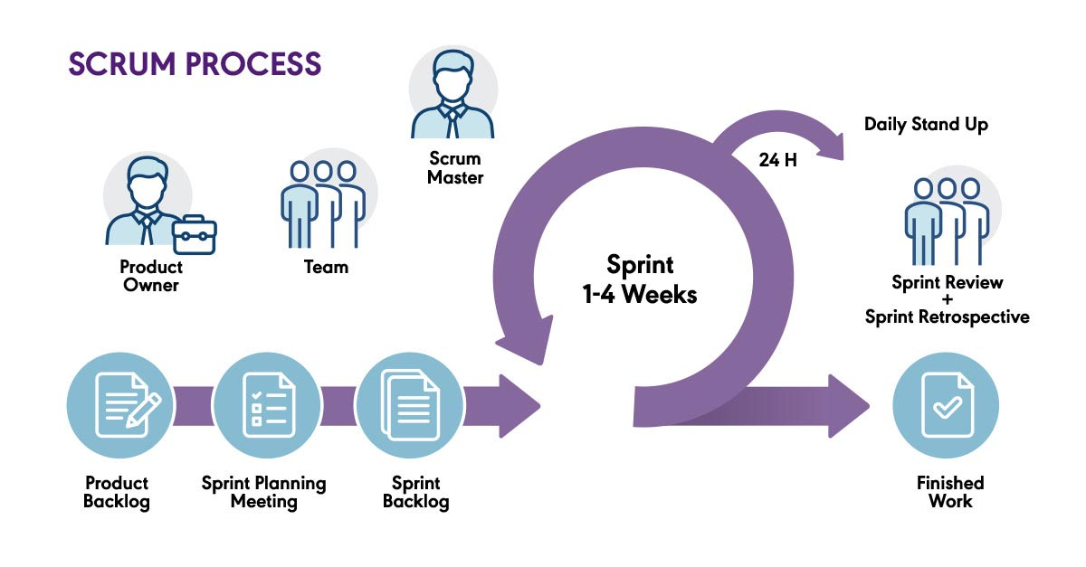

#### Figure 4‑1 Scrum Model

# Project Gantt Chart



#### Figure 5‑1 Gantt Chart

# Deliverables

1. **Software Requirements Specification (SRS) Document:** A detailed document outlining the functional and non-functional requirements of the SPA Management System.
2. **Initial Prototype:** An initial prototype demonstrating the basic functionalities of the SPA Management System, such as user authentication, appointment booking, and service management.
3. **Incremental Software Releases:** Regular releases of working software increments at the end of each sprint, showcasing the implemented features and functionalities.
4. **User Documentation:** Comprehensive documentation providing instructions on how to use the SPA Management System, including user guides, manuals, and FAQs.
5. **Administrator Documentation:** Specific documentation tailored for SPA administrators, detailing how to configure and manage the system, including employee management, service administration, and reporting.
6. **Test Cases and Test Reports:** Test cases for each feature of the SPA Management System, along with test reports documenting the results of testing activities, including unit tests, integration tests, and user acceptance tests.
7. **Deployment Package:** A deployment package containing the necessary files and instructions for deploying the SPA Management System in a production environment, including installation guides and system requirements.
8. **Training Materials:** Training materials, such as presentations and tutorials, to facilitate training sessions for SPA administrators and staff on how to use the SPA Management System effectively.

By delivering these key artifacts and milestones, the development team can ensure the successful development, deployment, and adoption of the SPA Management System, meeting the needs of SPA facilities and users while maintaining quality and reliability.

# References

Henkin, G. (2023, 02 09). *Spa Management: Challenges and Opportunities*. Retrieved from Cayuga Hospitality Consultants: https://cayugahospitality.com/gary-henkin/spa-management-challenges-and-opportunities/

Schwaber, K. (2022). *What is Scrum?* Retrieved from Scrum: https://www.scrum.org/learning-series/what-is-scrum/

Schwaber, K., & Sutherland, J. (2020). *The 2020 Scrum Guide*. Retrieved from Scrum Guides: https://scrumguides.org/scrum-guide.html

Smith, M. K., & Wallace, M. (2020, 09 17). *An analysis of key issues in spa management: viewpoints from international industry professionals*. Retrieved from ResearchGate: https://www.researchgate.net/publication/345028672_An_analysis_of_key_issues_in_spa_management_viewpoints_from_international_industry_professionals